 | 7-Minute
 |  |  | Appendix |  | L
 | SAFETY TRAINER
Emergency Phone Numbers
 | Type of Emergency |  |  | Phone Numbers

For fire emergency, call:

For medical
emergency, call:

For chemical emergency, call:
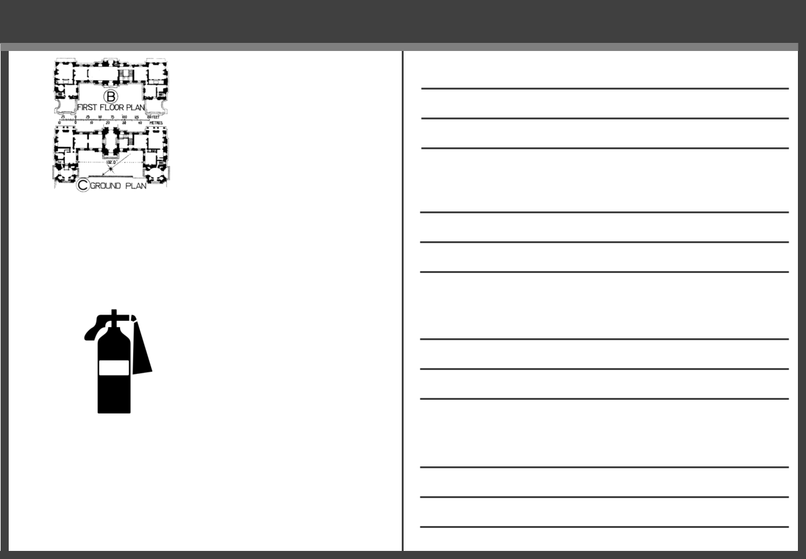

Evacuation Information

Where floor
plan is posted:

Nearest emergency exits:

Location of fire extinguishers:

Where to meet after an evacuation:

Supervisor: ____________________________________ Date: ____________________________

02/02/11001530 © BLR®—Business & Legal Resources

L

