Pre & Post – Trip Inspection Form Date: ………………………………

Drivers Name: |  | Start Mileage:
Registration Number: |  | Finish Mileage:
VOSA DG Card Number: |  | Start Time:
ADR Kit Bag Number: |  | Finish Time:
Arval Card |  | Texaco Card

Vehicle Check | OK | Y/N | Vehicle Check | OK | Y/N | Vehicle Check | Ok | Y/N
Oil |  |  | Water |  |  | Battery
Lights |  |  | Tyres |  |  | Wipers
Washers |  |  | Horn |  |  | Jack & Brace
Windscreen  (Cracks / Chips) |  |  | Spare Wheel |  |  | Leaks ( Oil or Other)

Stationary | Amount |  | Stationary | Amount |  | Packaging | Amount
 | Min | OB |  | Min | OB |  | Min | OB
Waybills | 20 |  | Lodging  Manifests | 20 |  | Bags Of Dry Ice | 2
Courier Pouches | 30 |  | Tracking Labels | 30 |  | Box 40 – 09 | 2
A5 Pacalopes | 30 |  | Spare Run Sheets | 20 |  | Box 57 -17 | 2
A5 Document  Envelopes | 30 |  | Trolley | 1 |  | Pathopaks | 4
Accident Report  Forms | 5 |  | Combination Box | 1 |  | Bio – Packs | 2
Drivers Handbook | 1 |  | Bio – Bags | 5 |  | Eurostar Shipment Instructions | 6

ADR Compliance

ADR DG Notes | 6 | Fire Extinguisher | 1 | Orange Plates | 2
Instructions In Writing Trem Card For UN2814 / UN 2900 | 6 | ADR Movement Check Sheets | 6
ADR Kit “ To be returned at the end of your shift” | 1 | VOSA Card (To be returned at the end of your shift

The VOSA DG Load Card whilst in your vehicle MUST be locked in the glove box as required by VOSA

Congestion zone entered: | Yes |  | No

IF YOU MAKE AN INCORRECT DECLARATION OR OMIT TO TICK THE CORRECT BOX YOU BECOME LIABLE FOR 50% ANY PENALTY INCURRED

Pre & Post Trip Inspection Form
Bodywork Inspection
Please indicate on the diagram below all damage/scratches or blemishes that are on the vehicle in the boxes provided below. Describe all damage and when first noticed by yourself. If damage scratches or blemishes have previously been noted then write “as previously advised”
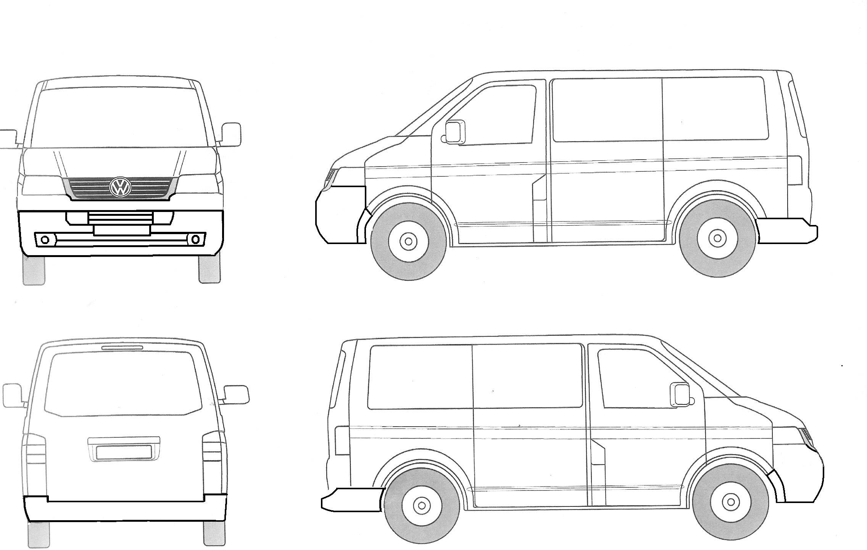
Describe Body Damage O/S & N/S:

Describe Body Damage Front & Rear:

Declaration: I declare the above mentioned vehicle was in my care during the period indicated above and that all the required checks were carried out. The named vehicle was road worthy at the start of my shift

In all cases notify the Transport Manager of any fresh damage

I Have Obtained the VOSA DG Load Card & ADR kit for my pre-trip

Drivers Signature Pre-Trip:__________________________________________

I have returned the VOSA DG load card & ADR kit

Vehicle refuelled at end of day: | Yes |  | No

Drivers Signature Post Trip:____________________________________________

Manager /Supervisors Signature Confirming Receipt:_______________________

