SYMPTOMS OF CORONAVIRUS DISEASE 2019

Patients with COVID-19 have experienced mild to

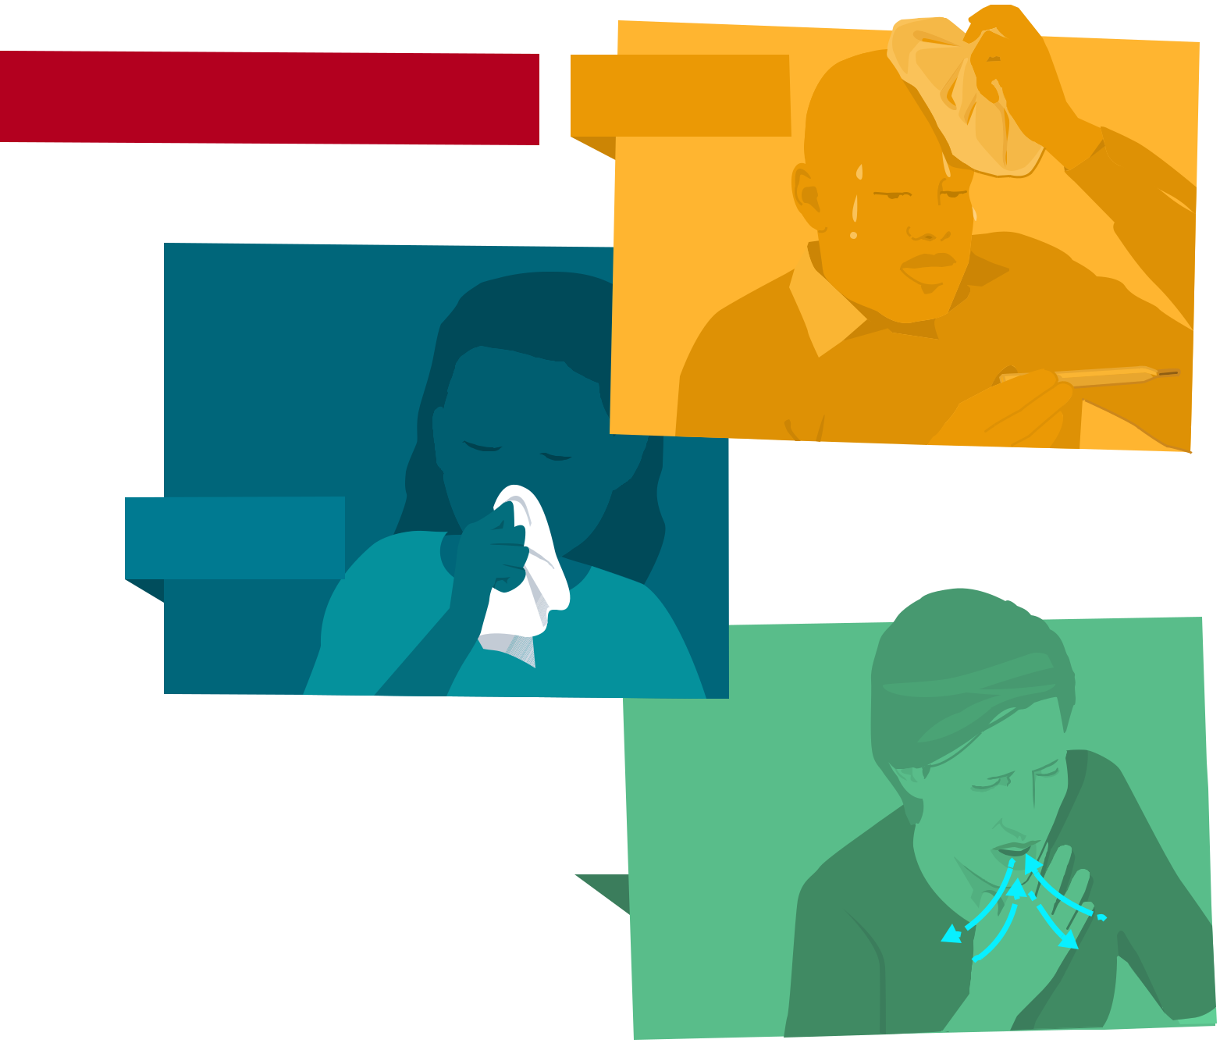
severe respiratory illness.

Symptoms* can include FEVER

COUGH | *Symptoms may appear 2-14
 | days after exposure.

Seek medical advice if you develop | SHORTNESS
symptoms, and have been in close | OF BREATH
contact with a person known to
have COVID-19 or if you live in or
have recently been in an area with
ongoing spread of COVID-19.

>INSERT LOGO<

