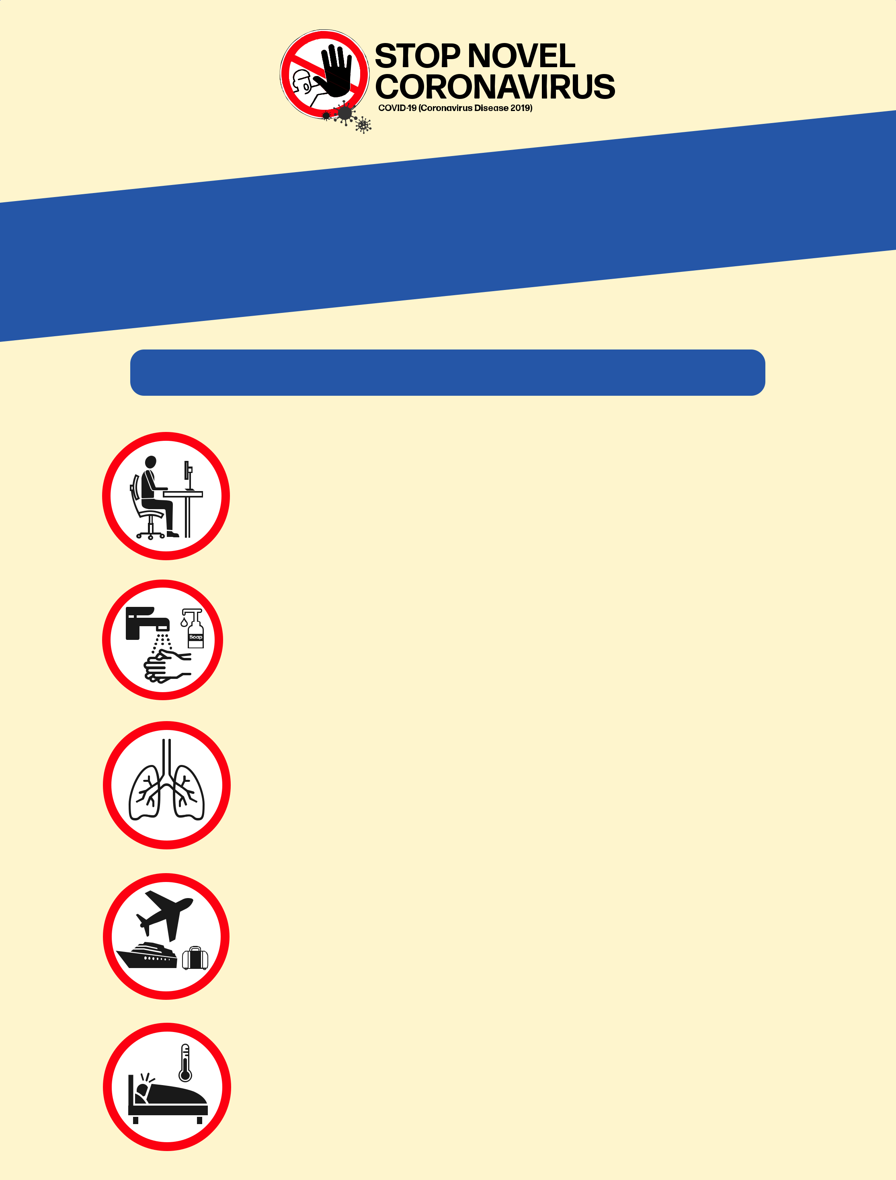

Getting | your workplace
 |  | -19
ready |  | for COVID

Protect your employees, contractors and customers

Keep the workplace clean and hygienic;

Promote regular and thorough hand-washing;

Promote good respiratory hygiene; cover your nose and mouth when coughing and sneezing;

Check Health Authorities’ travel advice before and after going on business;

Ensure those who are sick stay home.

