CORONAVIRUS
1 - Safe Place!
2 - Safe Person!
3 - Sound Information!
PROTECT YOURSELF & OTHERS
Version: 04
Issue Date: 22 March 2020 Time: 0230hrs (GMT)
Coronavirus (COVID-19)
Information Generic risk assessment (ongoing)

Table of Contents

1.0 Introduction 3
2.0 Number of coronavirus (COVID-19) cases and risk in the UK? 3
3.0 Symptoms of coronavirus 3
4.0 How coronavirus is spread 3
5.0 How to avoid catching and spreading coronavirus (social distancing) 4
6.0 What is social distancing? (General UK Government Guidance) 4
7.0 Social distancing in the workplace 5
8.0 Stay at home if you have coronavirus symptoms 5
9.0 Stay at home advice 5
10.0 How long to stay at home 6
11.0 Get an isolation note to give to your employer 6
12.0 If you have symptoms and live with a vulnerable person 6
13.0 Reducing the spread of infection in your home 7
14.0 How to do your cleaning and laundry 7
15.0 Looking after your health and wellbeing 7
16.0 What to do if someone develops symptoms of COVID-19 on site 7
17.0 Ending self-isolation and household isolation 8
18.0 Travel advice: coronavirus (COVID-19) 8
19.0 Preventing the spread of COVID-19 in the workplace 8
20.0 Handling post or packages 9
21.0 Treatment for coronavirus 9
APPENDIX 1: Awareness Poster 1 – Main Entrance 10
APPENDIX 2: Awareness Poster 2 – Wash Your Hands 11
APPENDIX 3: Awareness Poster 3 – How to wash your hands 12
APPENDIX 4: Awareness Poster 4 – If I am unwell, what should I do? 13
APPENDIX 5: Awareness Poster 5 – General Hygiene and avoid spreading 13
APPENDIX 6: Awareness Poster 6 – Employers and businesses guidance 15
APPENDIX 7: PHE Awareness Pack (Print and provide / email) 1 of 5 16
APPENDIX 8: Risk assessment – Safe place, Safe person, Sound information 21
Part 1: Risk assessment for coronavirus (COVID-19) 21
Part 2. Health & safety risk assessment - Briefing record 29
APPENDIX 9: Stay at Home guidance for households 30

Introduction
This guidance has been developed on information provided by:
- The UK NHS (National Health Service)
- The WHO (World Health Organisation)
- CIPD (The Chartered Institute of Personnel and Development)
- The UK FCO (Foreign and Commonwealth Office)
- GOV.UK
- Australian Government
- The Resuscitation Council (UK)
Date: 18th March 2020, 0300hrs
Coronaviruses (CoV) are a large family of viruses that cause illness ranging from the common cold to more severe diseases such as Middle East Respiratory Syndrome (MERS-CoV) and Severe Acute Respiratory Syndrome (SARS-CoV). A novel coronavirus (COVID-19) was identified in 2019 in Wuhan, China. This is a new coronavirus that has not been previously identified in humans.
Coronaviruses are zoonotic, meaning they are transmitted between animals and people. Detailed investigations found that SARS-CoV was transmitted from civet cats to humans and MERS-CoV from dromedary camels to humans. Several known coronaviruses are circulating in animals that have not yet infected humans.

Number of coronavirus (COVID-19) cases and risk in the UK?
As of 9am on 21 March 2020, 72,818 people have been tested in the UK, of which 67,800 were confirmed negative and 5,018 were confirmed positive.
As of 9am, 233 patients in the UK who tested positive for coronavirus (COVID-19) have died.
RISK LEVEL
The risk to the UK is HIGH.

Symptoms of coronavirus
The most common symptoms of coronavirus (COVID-19) are recent onset of:

- new continuous cough and/or
- high temperature

For most people, coronavirus (COVID-19) will be a mild infection

BBC Coronavirus symptoms video

How coronavirus is spread
Because it's a new illness, we do not know exactly how coronavirus spreads from person to person.
Similar viruses are spread in cough droplets.
It's very unlikely it can be spread through things like packages or food.

How to avoid catching and spreading coronavirus (social distancing)
Everyone should do what they can to stop coronavirus spreading. It is particularly important for people who:
- are 70 or over
- have a long-term condition
- are pregnant
- have a weakened immune system

DO
- wash your hands with soap and water often – do this for at least 20 seconds
- always wash your hands when you get home or into work
- use hand sanitiser gel if soap and water are not available
- cover your mouth and nose with a tissue or your sleeve (not your hands) when you cough or sneeze
- put used tissues in the bin immediately and wash your hands afterwards
- avoid close contact with people who have symptoms of coronavirus
- only travel on public transport if you need to
- work from home, if you can
- avoid social activities, such as going to pubs, restaurants, theatres and cinemas
- avoid events with large groups of people
- use phone, online services, or apps to contact your GP surgery or other NHS services

DO NOT
- do not touch your eyes, nose or mouth if your hands are not clean
- do not have visitors to your home, including friends and family

What is social distancing? (General UK Government Guidance)
Social distancing measures are steps you can take to reduce the social interaction between people. This will help reduce the transmission of coronavirus (COVID-19).
They are:
- Avoid contact with someone who is displaying symptoms of coronavirus (COVID-19). These symptoms include high temperature and/or new and continuous cough
- Avoid non-essential use of public transport, varying your travel times to avoid rush hour, when possible
- Work from home, where possible. Your employer should support you to do this. Please refer to employer guidance for more information
- Avoid large gatherings, and gatherings in smaller public spaces such as pubs, cinemas, restaurants, theatres, bars, clubs
- Avoid gatherings with friends and family. Keep in touch using remote technology such as phone, internet, and social media
- Use telephone or online services to contact your GP or other essential services
Everyone should be trying to follow these measures as much as is pragmatic.
We strongly advise you to follow the above measures as much as you can and to significantly limit your face-to-face interaction with friends and family if possible, particularly if you:
- are over 70
- have an underlying health condition
- are pregnant
This advice is likely to be in place for some weeks.

Social distancing in the workplace
To reduce the spread of germs in the workplace:
- Stay at home if you are sick
- Stop handshaking as a greeting
- Hold meetings via video conferencing or phone call
- Defer large meetings
- Hold essential meetings outside in the open air if possible
- Promote good hand and sneeze/cough hygiene and provide hand sanitisers for all staff and workers
- Take lunch at your desk or outside rather than in the lunchroom
- Clean and disinfect high touch surfaces regularly
- Consider opening windows and adjusting air conditioning for more ventilation
- Limit food handling and sharing of food in the workplace
- Reconsider non-essential business travel
- Promote strictest hygiene among food preparation (canteen) staff and their close contacts
- Consider if large gatherings can be rescheduled, staggered or cancelled.

Stay at home if you have coronavirus symptoms
Stay at home if you have either:
- a high temperature – this means you feel hot to touch on your chest or back (you do not need to measure your temperature)
- a new, continuous cough – this means coughing a lot for more than an hour, or 3 or more coughing episodes in 24 hours (if you usually have a cough, it may be worse than usual)
Do not go to a GP surgery, pharmacy or hospital.
USE THE NHS 111 ONLINE CORONAVIRUS SERVICE TO FIND OUT WHAT TO DO.
Link: https://111.nhs.uk/covid-19/
Only call 111 if you cannot get help online.

Stay at home advice
Staying at home can help stop coronavirus spreading
You'll need to stay at home if you have symptoms of coronavirus (COVID-19) or live with someone who does.
Staying at home means you should;
- not go to work, school or public areas
- not use public transport or taxis
- not have visitors, such as friends and family, in your home
- not go out to buy food or collect medicine – order them by phone or online, or ask someone else to drop them off at your home
You can use your garden, if you have one. You can also leave the house to exercise – but stay at least 2 metres away from other people.
If you're not sure if you need to stay at home
If you have symptoms of coronavirus (a high temperature or a new, continuous cough), use the 111-coronavirus service to find out what to do.

How long to stay at home
If you have symptoms
If you have symptoms of coronavirus, you'll need to stay at home for 7 days.
After 7 days:
- if you do not have a high temperature, you do not need to stay at home
- if you still have a high temperature, stay at home until your temperature returns to normal
You do not need to stay at home if you just have a cough after 7 days. A cough can last for several weeks after the infection has gone.
If you live with someone who has symptoms
If you live with someone who has symptoms, you'll need to stay at home for 14 days from the day their symptoms started. This is because it can take 14 days for symptoms to appear.
If more than 1 person at home has symptoms, stay at home for 14 days from the day the first person started having symptoms.
If you get symptoms, stay at home for 7 days from when your symptoms start, even if it means you're at home for longer than 14 days.
If you do not get symptoms, you can stop staying at home after 14 days.

Get an isolation note to give to your employer
If you live with someone who has symptoms of coronavirus, you can get an isolation note to send to your employer as proof you need to stay off work.
You do not need to get a note from a GP.
If you have symptoms of coronavirus and need to stay at home, use the 111-coronavirus service to get an isolation note
Get an isolation note
Link: https://111.nhs.uk/isolation-note/

If you have symptoms and live with a vulnerable person
If you live with someone who is 70 or over, has a long-term condition, is pregnant or has a weakened immune system, try to arrange for them to stay with friends or family for 14 days.

If you have to stay at home together, try to keep away from each other as much as possible.
DO
- try to keep 2 metres (3 steps) away from each other
- avoid using shared spaces, such as kitchens or bathrooms, at the same time as each other
- open windows in shared spaces if you can
- clean a shared bathroom each time you use it, for example by wiping the surfaces you have touched
- use a dishwasher if you have one – if you do not have one, use washing-up liquid and warm water and dry everything thoroughly
DO NOT
- do not share a bed, if possible
- do not share towels, including hand towels and tea towels

Reducing the spread of infection in your home
While you're staying at home, you should:
- wash your hands with soap and water often, for at least 20 seconds
- use hand sanitiser gel if soap and water are not available
- cover your mouth and nose with a tissue or your sleeve (not your hands) when you cough or sneeze
- put used tissues in the bin straight away and wash your hands afterwards
- clean objects and surfaces you touch often (like door handles, kettles and phones) using your regular cleaning products

How to do your cleaning and laundry
Use your usual household products, such as detergents and bleach, when you clean your home.
Put used tissues and disposable cleaning cloths in rubbish bags. Then put the bag into a second bag and tie it securely. Wait 3 days before putting it in your outside bin.
Dispose of other household waste as normal.
Wash your laundry in the washing machine in the usual way. Laundry that has been in contact with an ill person can be washed with other people's items. Do not shake dirty laundry, as this may spread the virus in the air.
If you do not have a washing machine, wait for 3 days after your stay at home has ended before taking your laundry to a launderette.

Looking after your health and wellbeing
To help yourself stay well while you're at home:
- drink plenty of water to stay hydrated – drink enough so your pee is pale and clear
- take paracetamol to help ease your symptoms
- stay in touch with family and friends over the phone or on social media, to help you avoid feeling low or lonely
- try to keep yourself busy – you could try activities like cooking, reading, online learning and watching films
- do light exercise, if you feel well enough to

What to do if someone develops symptoms of COVID-19 on site
If anyone becomes unwell with a new, continuous cough or a high temperature in the business or workplace they should be sent home and advised to follow the stay at home guidance.
If they need clinical advice, they should go online to NHS 111 or call 111 if they don’t have internet access. In an emergency, call 999 if they are seriously ill or injured or their life is at risk. Do not visit the GP, pharmacy, urgent care centre or a hospital.
If a member of staff has helped someone who was taken unwell with a new, continuous cough or a high temperature, they do not need to go home unless they develop symptoms themselves. They should wash their hands thoroughly for 20 seconds after any contact with someone who is unwell with symptoms consistent with coronavirus infection.
It is not necessary to close the business or workplace or send any staff home, unless government policy changes. Keep monitoring the government response page for the latest details.
Travel arrangements
Anyone who has a new, continuous cough or a high temperature should be advised to quickly and directly return home and to remain there and initiate household isolation. If they have to use public transport, they should try to keep away from other people and catch coughs and sneezes in a tissue.

Ending self-isolation and household isolation
Self-isolation
If you have been symptomatic, then you may end your self-isolation after 7 days. The 7-day period starts from the day when you first became ill
Household isolation
If living with others, then all household members who remain well may end household-isolation after 14 days. The 14-day period starts from the day illness began in the first person to become ill. Fourteen days is the incubation period for coronavirus; people who remain well after 14 days are unlikely to be infectious.
After 7 days, if the first person to become ill feels better and no longer has a high temperature, they can return to their normal routine. If any other family members become unwell during the 14-day household-isolation period, they should follow the same advice - that is, after 7 days of their symptoms starting, if they feel better and no longer have a high temperature, they can also return to their normal routine.
Should a household member develop coronavirus symptoms late in the 14-day household-isolation period (for example, on day 13 or day 14) the isolation period does not need to be extended, but the person with the new symptoms has to stay at home for 7 days. The 14-day household-isolation period will have greatly reduced the overall amount of infection the rest of the household could pass on, and it is not necessary to restart 14 days of isolation for the whole household. This will have provided a high level of community protection. Further isolation of members of this household will provide very little additional community protection.
At the end of the 14-day period, any family member who has not become unwell can leave household isolation.
If any ill person in the household has not had any signs of improvement and have not already sought medical advice, they should contact NHS 111 online. If your home has no internet access, you should call NHS 111.
The cough may persist for several weeks in some people, despite the coronavirus infection having cleared. A persistent cough alone does not mean someone must continue to self-isolate for more than 7 days.

Travel advice: coronavirus (COVID-19)
Guidance for British people travelling and living overseas following the outbreak of coronavirus (COVID-19).
Foreign & Commonwealth Office (FCO) travel advice
The Foreign & Commonwealth Office (FCO) now advises British people against all non-essential travel worldwide. This advice takes effect immediately and applies initially for a period of 30 days.

Preventing the spread of COVID-19 in the workplace
Low-cost measures below will help prevent the spread of infections in the workplace, such as colds, flu and stomach bugs, and protect your customers, contractors and employees.
Employers should start doing these things now, even if COVID-19 has not arrived in the communities where they operate. They can already reduce working days lost due to illness and stop or slow the spread of COVID-19 if it arrives at one of your workplaces.
- Make sure your workplaces are clean and hygienic
  - Surfaces (e.g. desks and tables) and objects (e.g. telephones, keyboards) need to be wiped with disinfectant regularly
  - Why? Because contamination on surfaces touched by employees and customers is one of the main ways that COVID-19 spreads
- Promote regular and thorough handwashing by employees, contractors and customers
  - Put sanitizing hand rub dispensers in prominent places around the workplace. Make sure these dispensers are regularly refilled
  - Display posters promoting hand-washing–ask your local public health authority for these or look on www.WHO.int.
  - Combine this with other communication measures such as offering guidance from occupational health and safety officers, briefings at meetings and information on the intranet to promote handwashing
  - Make sure that staff, contractors and customers have access to places where they can wash their hands with soap and water
  - Why? Because washing kills the virus on your hands and prevents the spread of COVID - 19

Handling post or packages
Staff should continue to follow existing risk assessments and safe systems of working; there are no additional precautions needed for handling post or packages.

Treatment for coronavirus
- There is currently no specific treatment for coronavirus
- Antibiotics do not help, as they do not work against viruses
- Treatment aims to relieve the symptoms while your body fights the illness
- You'll need to stay in isolation away from other people until you've recovered.

APPENDIX 1: Awareness Poster 1 – Main Entrance
CORONAVIRUS
------------------------------------------------------------------------------------------------------------------------------------------------
Are you suffering from the following signs and symptoms?

- Cough
- Fever
- Difficulty in breathing / shortness of breath

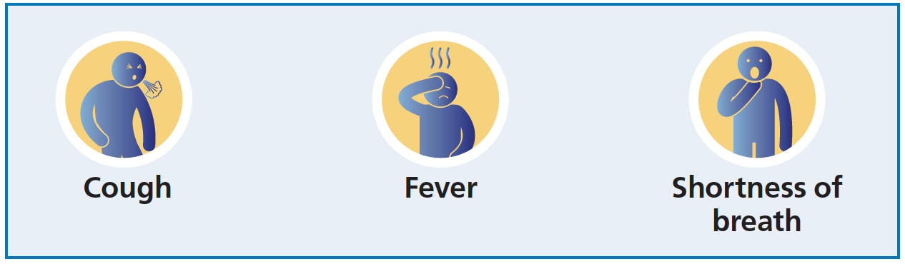

If yes, to protect yourself and others please go home and search ‘NHS Coronavirus’ for advice and access the 111 online coronavirus service.

As soon as possible contact your Employer for guidance.

Do not enter this building

Poster layout and content developed from NHS and Public Health England.

APPENDIX 2: Awareness Poster 2 – Wash Your Hands
CORONAVIRUS
------------------------------------------------------------------------------------------------------------------------------------------------
Wash your hands

more often for

20 seconds

Use soap and water or a hand sanitiser when you:

- Get home or into work
- Blow your nose, sneeze or cough
- Eat or handle food
CORONAVIRUS
1 - Safe Place!
2 - Safe Person!
3 - Sound Information!
PROTECT YOURSELF & OTHERS

Poster layout and content developed from NHS and Public Health England.

APPENDIX 3: Awareness Poster 3 – How to wash your hands
CORONAVIRUS
------------------------------------------------------------------------------------------------------------------------------------------------

Wash your hands with soap and water more often for 20 seconds

Palm to palm The backs of hands In between the fingers

The back of the fingers The thumbs The tips of the fingers

Use a tissue to turn off the tap.
Dry hands thoroughly.

Poster layout and content developed from the NHS.

APPENDIX 4: Awareness Poster 4 – If I am unwell, what should I do?

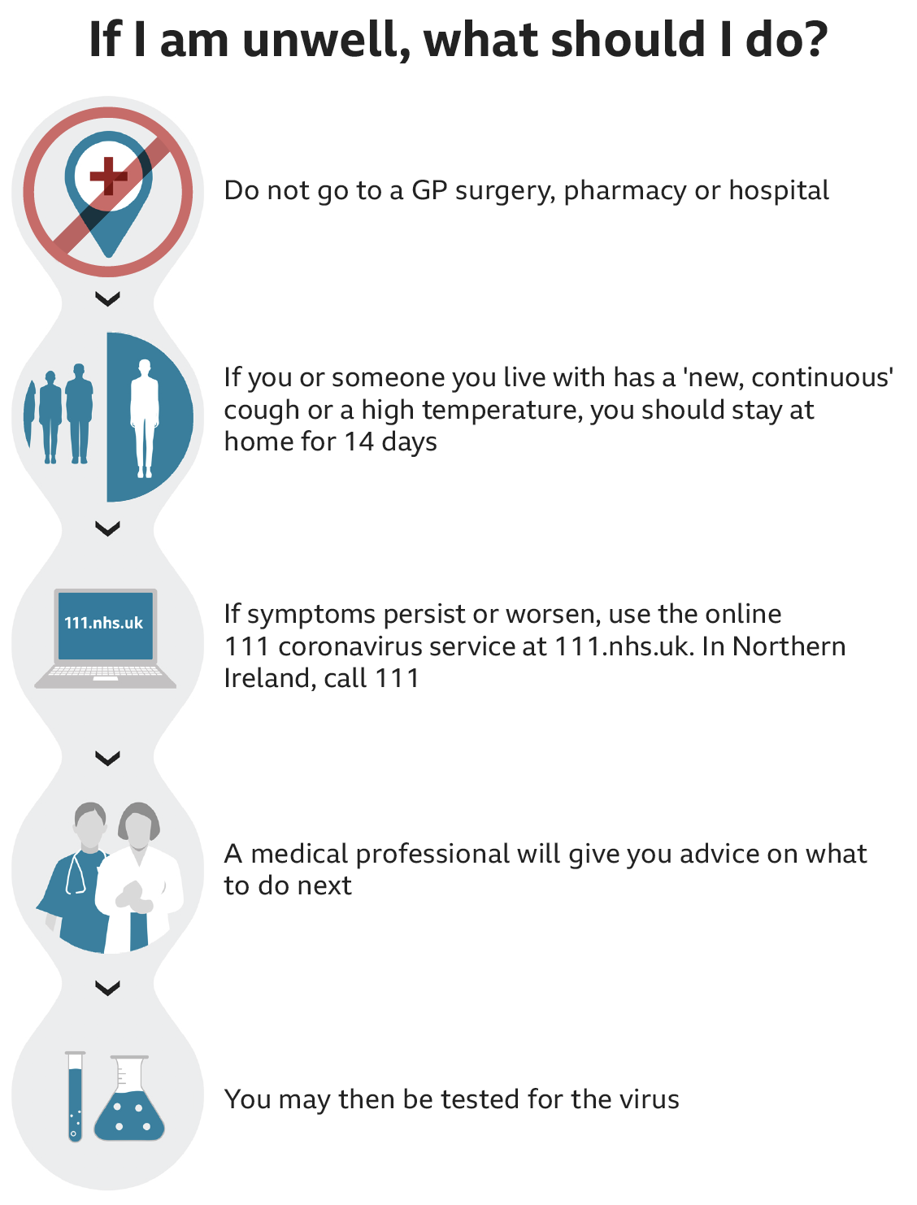
APPENDIX 5: Awareness Poster 5 – General Hygiene and avoid spreading
CORONAVIRUS
------------------------------------------------------------------------------------------------------------------------------------------------
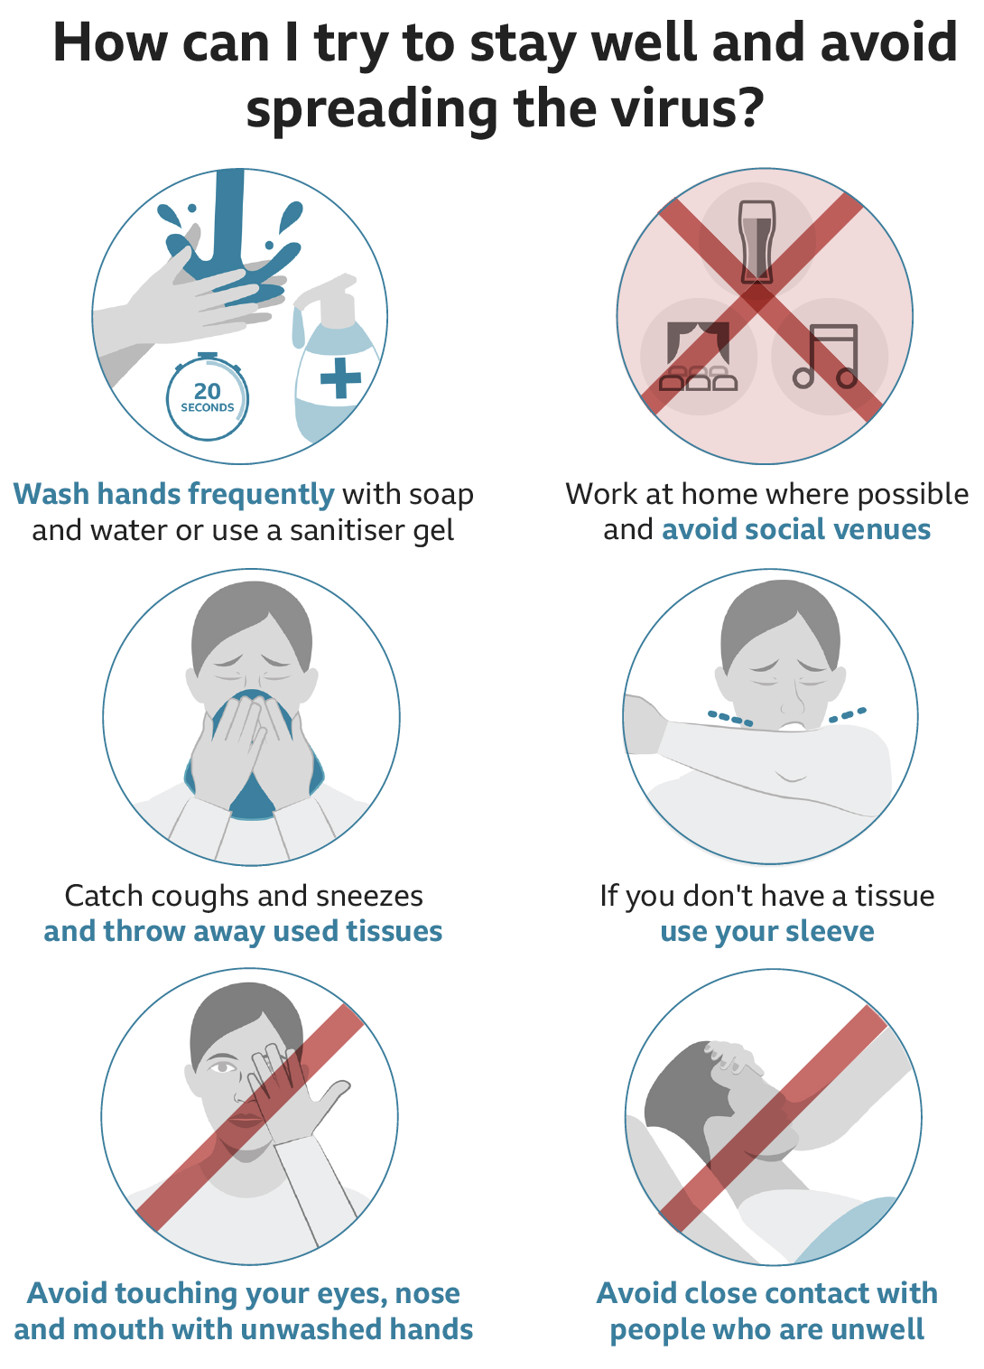

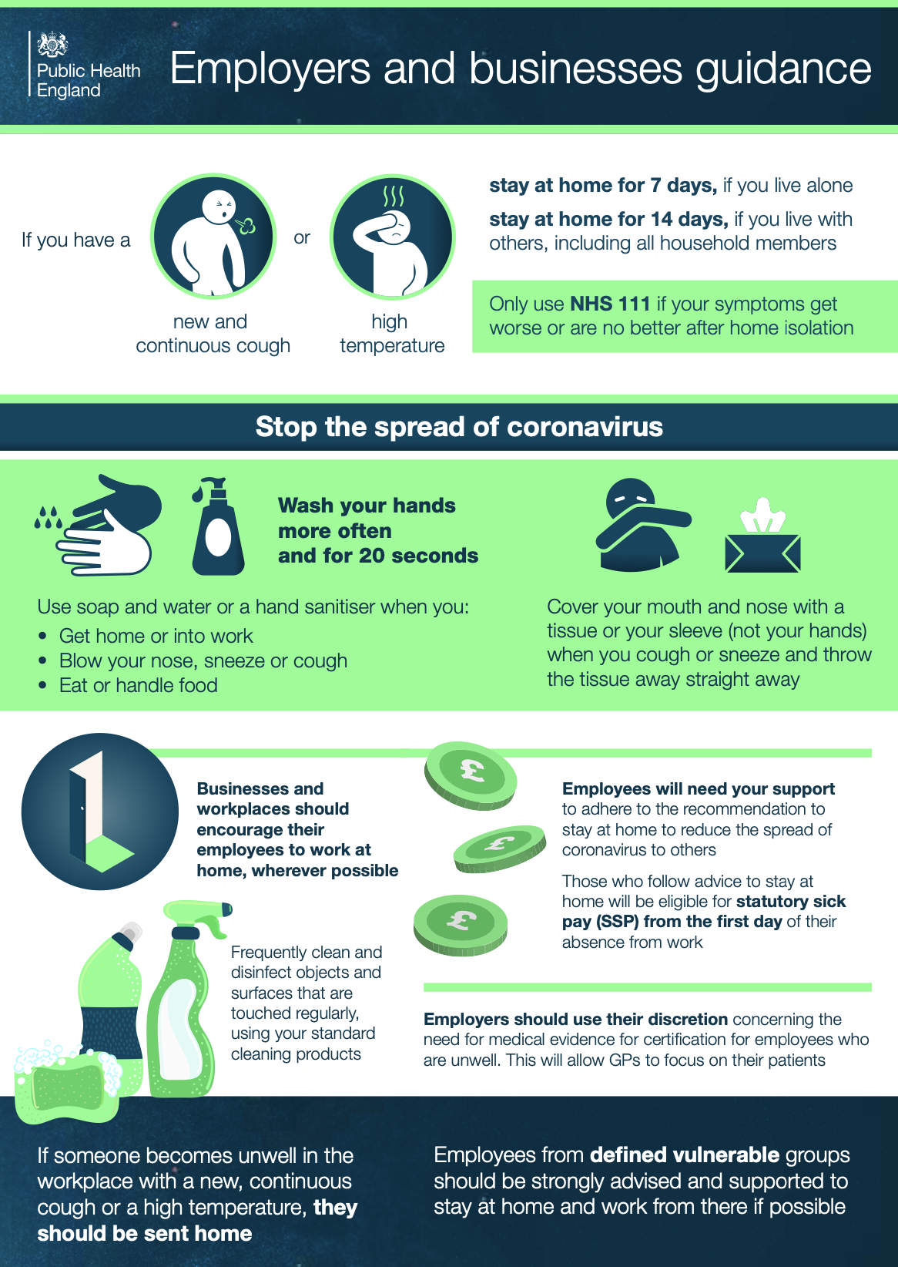
APPENDIX 6: Awareness Poster 6 – Employers and businesses guidance

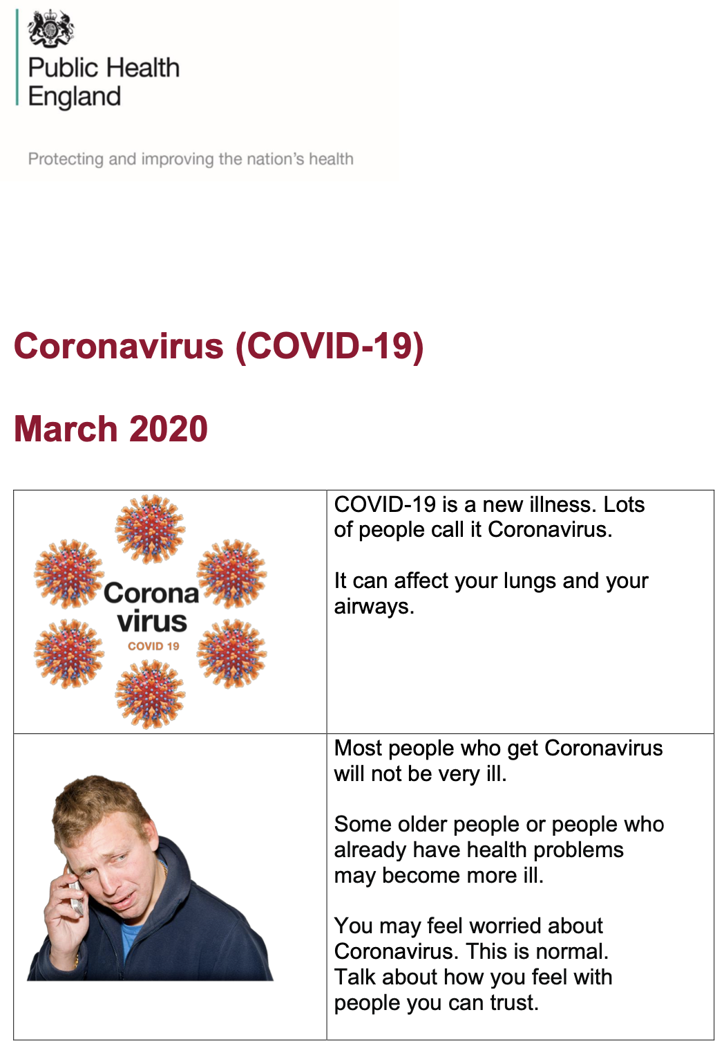
APPENDIX 7: PHE Awareness Pack (Print and provide / email) 1 of 5

PHE Awareness Pack (Print and provide / email) 2 of 5

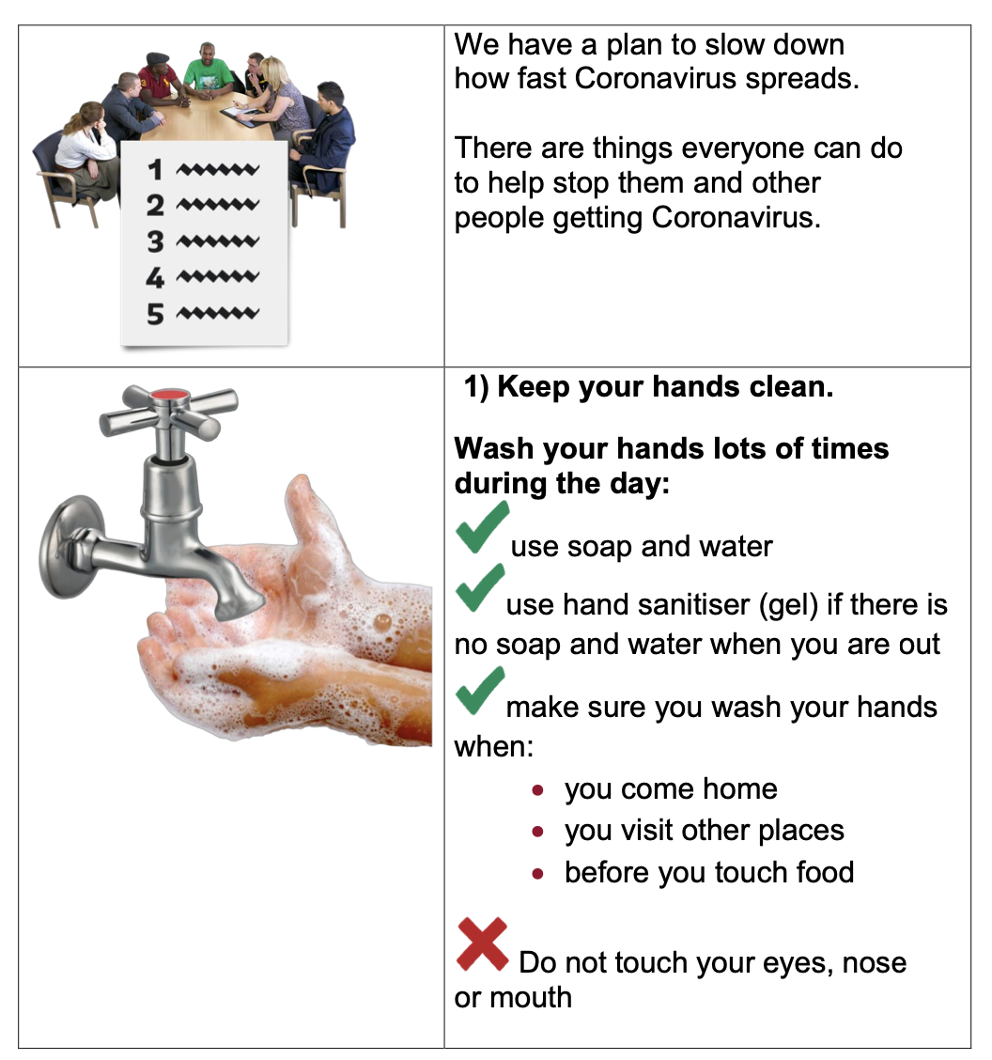

PHE Awareness Pack (Print and provide / email) 3 of 5

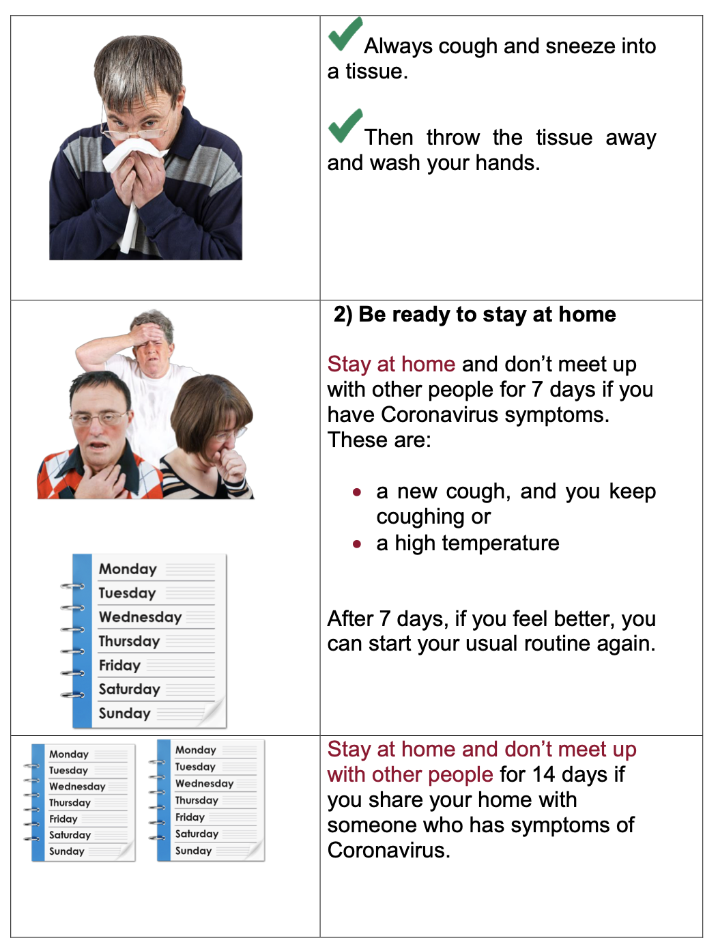

PHE Awareness Pack (Print and provide / email) 4 of 5

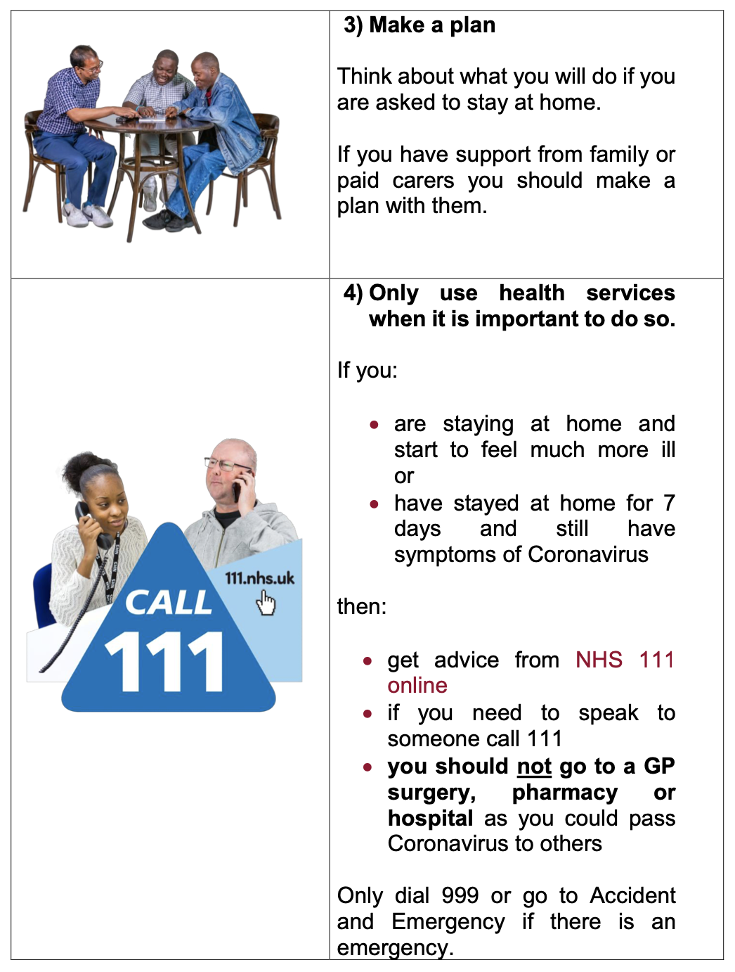

PHE Awareness Pack (Print and provide / email) 5 of 5

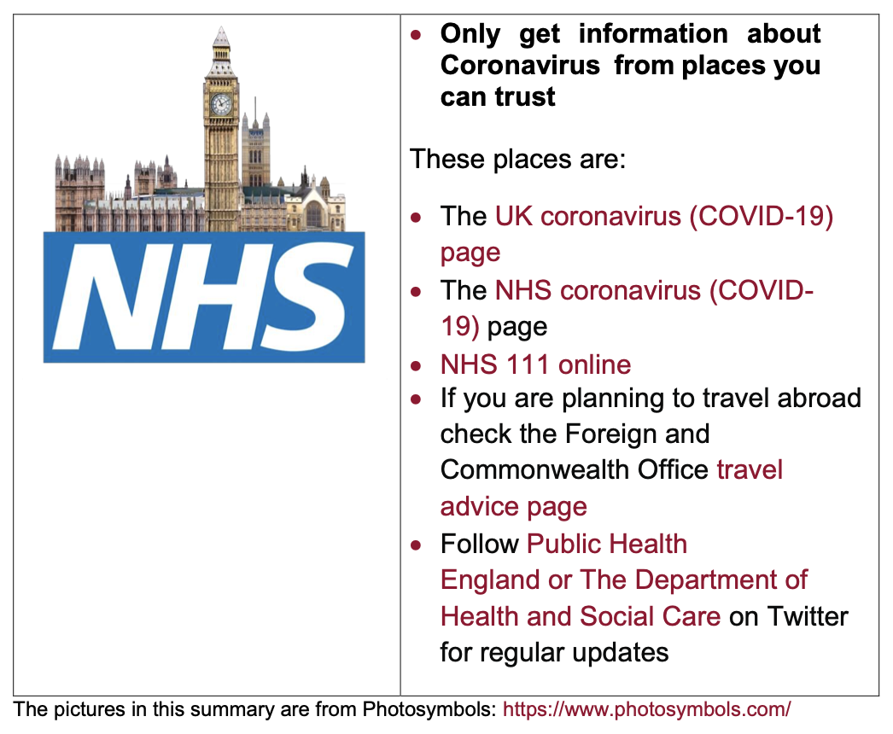

APPENDIX 8: Risk assessment – Safe place, Safe person, Sound information

Part 1: Risk assessment for coronavirus (COVID-19)
Risk assess each hazard and implement the necessary controls as appropriate. Provide awareness briefings to all affected workers and contractors, use the briefing record to capture their names. Note: The assessment has been started – add to the assessment as appropriate.
Description
Prepared by (print) |  |  |  | Prepared by (sign) |  |  |  |  | Position |  |  |  | Date
Authorised by (print) |  |  |  | Authorised by (sign) |  |  |  |  | Position |  |  |  | Date
Risk  No. | Hazard |  | Who might be affected and how? |  | Enter either, or/and  1 - Details of recommended NHS / UK Government / FCO / WHO / etc. / General health and safety risk management controls (zoonosis)  2 - What we are currently doing |  | Evaluate current control measures.  Do we need to implement additional controls? |  |  |  | Enter either, or/and  1 - New control measures recommended  2 - Why the recommended control measures are not implemented  3 - General comments | By who |  |  | By when
 |  |  |  |  |  |  | YES | NO |  | N/A
1 - SAFE PLACE
R1 | Coronavirus  (COVID-19) (CV19)  Someone entering the workplace with CV19 |  | Employees  A visitor enters the workplace with CV19 and passes the virus on to employees. |  | 1 - An information poster/email is sent to regular visitors which highlights the risks of CV19 and states that symptomatic individuals will not be allowed entry or will be requested to leave.  2 - An information poster highlighting the symptoms of CV19 is placed on the entry/sign in point. The poster will state that symptomatic individuals will not be allowed entry.  3 - Hygiene requirements (handwashing etc.) and symptoms of CV19 will be included within Induction.  4 - CV19 Information posters are placed in designated locations within the workplace (toilets, notice boards etc).  5 - This information has been passed onto employees.
R2 | Coronavirus  (COVID-19) (CV19)  Someone becomes ill within the workplace |  | Employees, visitors  Contracted CV19 by any means. |  | 1 - Person will be removed to a designated area which is at least 2 metres away from other people.  2 - We have identified a designated room or area where they can be isolated behind a closed door, such as a staff office. If it is possible to open a window, we will do so for ventilation.  3 - The individual will be sent home and advised to follow NHS guidance online. If the person is a visitor, their organisation will also be contacted.  4 - The workplace will be decontaminated following Governmental guidance:  https://www.gov.uk/government/publications/covid-19-decontamination-in-non-healthcare-settings/covid-19-decontamination-in-non-healthcare-settings  5 - This information has been passed onto employees.
R3 | Coronavirus  (COVID-19) (CV19)  Contaminated workplace |  | Employees, visitors  A person catches CV19 due to contaminated surfaces. |  | 1 - An increased formal cleaning regime is underway. Employees are cleaning equipment more often (keyboards, work surfaces, door handles etc.).  2 - Hand sanitisers have been placed in the workplace.  3 - Extra hygiene requirements (handwashing etc.) are enforced.  4 - Multi-use handtowels are not used to dry hands.  5 - This information has been passed onto employees.
R4 | Coronavirus  (COVID-19) (CV19)  Proximity, workplace gatherings |  | Employees  A person catches CV19 due to working closely with an infected person. |  | 1 - A Social Distancing policy has been implemented. All work areas and activities have been evaluated against the possibility to implement social distancing (no handshaking, deferring large meetings etc.)  https://www.health.gov.au/resources/publications/coronavirus-covid-19-information-on-social-distancing  2 - This information has been passed onto employees.
Risk  No. | Hazard |  | Who might be affected and how? |  | Enter either, or/and  1 – Details of recommended NHS / UK Government / FCO / WHO / etc. / General health and safety risk management controls (zoonosis)  2 – What we are currently doing |  | Evaluate current control measures.  Do we need to implement additional controls? |  |  |  | Enter either, or/and  1 – New control measures recommended  2 – Why the recommended control measures are not implemented  3 – General comments | By who |  |  | By when
 |  |  |  |  |  |  | YES | NO |  | N/A
2 – SAFE PERSON
R5 | Coronavirus  (COVID-19) (CV19)  General |  | Employees (including those considered at increased risk)  Employees are not aware of the risks from CV19 and become infected due to lack of awareness of control measures. |  | 1 – NHS provides advice on what CV19 is, what the risks are, the symptoms, how CV19 is spread, and how to avoid catching or spreading germs (simple Do’s and Don’ts):  https://www.nhs.uk/conditions/coronavirus-covid-19/  2 – The WHO (World Health Organisation) provides information and a free 5-minute video on which has been provided to our employees CV19:  https://openwho.org/courses/introduction-to-ncov  3 – Government guidance on hand washing is provided in line with the 20 second rule:  https://www.nhs.uk/video/pages/how-to-wash-hands.aspx  4 – Additional consideration will be given to those employees who may be deemed to be at increased risk.  5 – Advice on risks, symptoms and control measures has been passed onto employees. A formal training program has been implemented which considers Safe Place, Safe Person, Sound Information.
R6 | Coronavirus  (COVID-19) (CV19)  Self-isolation |  | Employees  Employees are not aware of the need to self-isolate or how to self-isolate. |  | 1 – NHS 111 online provides advice on when to self-isolate and access to an online interactive and personal checklist:  https://www.nhs.uk/conditions/coronavirus-covid-19/self-isolation-advice/  2 – The need to provide an isolation certificate has been passed to employees.  3 – Advice on how to self-isolate has been passed onto employees.
R7 | Coronavirus  (COVID-19) (CV19)  Travel  (Travelling abroad) |  | Employees  Travelling abroad for work to an area with a higher risk of CV19. |  | 1 – FCO provides advice for travellers:  https://www.gov.uk/foreign-travel-advice (FCO)  2 – UK Government advises against all non-essential travel.  3 – Practical alternatives to travel including postponing trips and holding meetings via video conferencing are implemented.  4 – Advice and guidance on travelling has been passed onto employees.
R8 | Coronavirus  (COVID-19) (CV19)  Travel  (Returning from travelling abroad) |  | Employees  Returning to the UK after travelling abroad for work (or otherwise) to an area with a higher risk of CV19. |  | 1 – CIPD provides advice for travellers returning to work from affected areas:  https://www.hr-inform.co.uk/news-article/advice-on-managing-the-coronavirus-outbreak (CIPD)  2 – We will not insist employees travel to an area with a higher risk of CV19.  3 – This advice or how to access it is passed onto employees.
R9 | Coronavirus  (COVID-19) (CV19)  Booked annual leave |  | Employees  Employee(s) may become affected due to travelling to an affected area as part of booked annual leave. |  | 1 – Employee(s) are granted permission to cancel at short notice any pre-booked annual leave to an affected area.  (a failure to allow short notice cancellation could pressure employees to travel to affected destinations).
R10 | Coronavirus  (COVID-19) (CV19)  Symptomatic or exposed employee(s)  Presenteeism |  | Employees, general public, family members  Employee(s) is/are symptomatic of CV19 or has been in close contact with someone with CV19.  A person catches CV19 due to another employee continuing to work despite being unwell. |  | 1 – Employee(s) is/are advised to follow NHS online guidance:  https://www.nhs.uk/conditions/coronavirus-covid-19/  2 – If NHS 111 or a GP determines the employee is symptomatic and certifies them unfit for work, they will be treated as off sick as per normal policy.  3 – Symptomatic employees will be sent home.  4 – Colleagues who have had contact with a symptomatic employee will be made aware of the symptoms and advised to contact NHS online for guidance.  5 – Working from home will be considered. A specific homeworking risk assessment will be conducted.  6 – As a last resort, if we decide to suspend an employee as a precaution this will be on full pay unless the employees specific contract provides us a right to suspend without full pay for this reason. Such a suspension will not be considered a ‘medical suspension’.  7 – This advice or how to access it is passed onto employees.
R11 | Coronavirus  (COVID-19) (CV19)  Employee(s) who have contracted CV19 |  | Employees, general public, family members  Contracted CV19 by any means. |  | 1 – If NHS 111/online or a GP determines an employee has contracted CV19 they will be treated as off sick as per normal policy.  2 – Colleagues who have had contact with a symptomatic employee will be made aware of the symptoms and advised to follow NHS online guidance.  3 – The workplace will be decontaminated following Governmental guidance:  https://www.gov.uk/government/publications/covid-19-decontamination-in-non-healthcare-settings/covid-19-decontamination-in-non-healthcare-settings  4 – Personal Protective Equipment has been provided relative to activities.  5 – This information has been passed onto employees.
R13 | Coronavirus  (COVID-19) (CV19)  First Aid Training / CPR Manikin |  | Employees  Employees are exposed to risks from CV19 due to providing First Aid in the workplace,  or,  from the use of CPR Training on Manikins. |  | 1 – Advice on CPR and resuscitation in the workplace is taken from UK Gov & the Resuscitation Council:  https://www.resus.org.uk/media/statements/resuscitation-council-uk-statements-on-covid-19-coronavirus-cpr-and-resuscitation/covid-community/  https://www.gov.uk/government/publications/novel-coronavirus-2019-ncov-interim-guidance-for-first-responders/interim-guidance-for-first-responders-and-others-in-close-contact-with-symptomatic-people-with-potential-2019-ncov  2 – Advice on Manikin Hygiene is sought from reputable providers.  https://www.qualsafe.com/PDFs/QA%20COVID-19%20Info.pdf
Risk  No. | Hazard |  | Who might be affected and how? |  | Enter either, or/and  1 - Details of recommended NHS / UK Government / FCO / WHO / etc. / General health and safety risk management controls (zoonosis)  2 - What we are currently doing |  | Evaluate current control measures.  Do we need to implement additional controls? |  |  |  | Enter either, or/and  1 - New control measures recommended  2 - Why the recommended control measures are not implemented  3 - General comments | By who |  |  | By when
 |  |  |  |  |  |  | YES | NO |  | N/A
3 - SOUND INFORMATION
R12 | Coronavirus  (COVID-19) (CV19)  Lack of accurate information / a failure to disseminate information |  | Employees (including those considered at increased risk)  Employees are not aware of the risks from CV19 and become infected due to lack of awareness of control measures. |  | 1 - Monitoring. We have designated a CV19 Appointed Person. Responsibilities include:  - Signing up to the UK Gov CP immediate updates:  https://www.gov.uk/email-signup?link=/government/topical-events/coronavirus-covid-19-uk-government-response  - Monitoring relevant Websites and News outlets.  2 - Reporting. An internal and external risk communication plan has been developed to ensure timely updating/ sharing of information with all stakeholders (meetings, circulars, emails etc.).

Part 2. Health & safety risk assessment - Briefing record
If the risk assessment is updated the briefing of the changes must be recorded.
By signing below, I acknowledge that I have received a health and safety briefing on the topic(s) covered by the above risk assessment
First name | Surname | Signature | Time | Date |  | First name | Surname | Signature | Time | Date
Guidance Note – IMPORTANT: If you feel your health, safety or security is at risk at any time, you must stop work immediately and seek advice.

APPENDIX 9: Stay at Home guidance for households
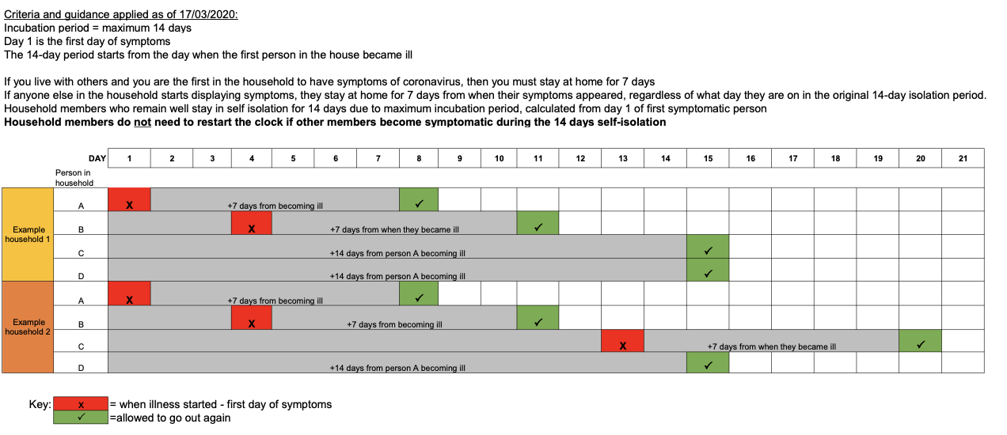

https://www.gov.uk/guidance/coronavirus-covid-19-information-for-the-public#number-of-cases
https://www.gov.uk/government/publications/covid-19-stay-at-home-guidance/stay-at-home-guidance-for-people-with-confirmed-or-possible-coronavirus-covid-19-infection#symptoms
https://www.bbc.co.uk/news/explainers
https://www.nhs.uk/conditions/coronavirus-covid-19/
https://www.nhs.uk/conditions/coronavirus-covid-19/
https://www.health.gov.au/resources/publications/coronavirus-covid-19-information-on-social-distancing
https://www.nhs.uk/conditions/coronavirus-covid-19/
https://www.nhs.uk/conditions/coronavirus-covid-19/self-isolation-advice/
https://www.nhs.uk/conditions/coronavirus-covid-19/self-isolation-advice/
https://www.nhs.uk/conditions/coronavirus-covid-19/self-isolation-advice/
https://www.gov.uk/government/publications/guidance-to-employers-and-businesses-about-covid-19/guidance-for-employers-and-businesses-on-coronavirus-covid-19
https://www.gov.uk/government/publications/covid-19-stay-at-home-guidance/stay-at-home-guidance-for-households-with-possible-coronavirus-covid-19-infection#ending-isolation
https://www.gov.uk/guidance/travel-advice-novel-coronavirus
https://www.who.int/docs/default-source/coronaviruse/getting-workplace-ready-for-covid-19.pdf
https://www.nhs.uk/conditions/coronavirus-covid-19/

