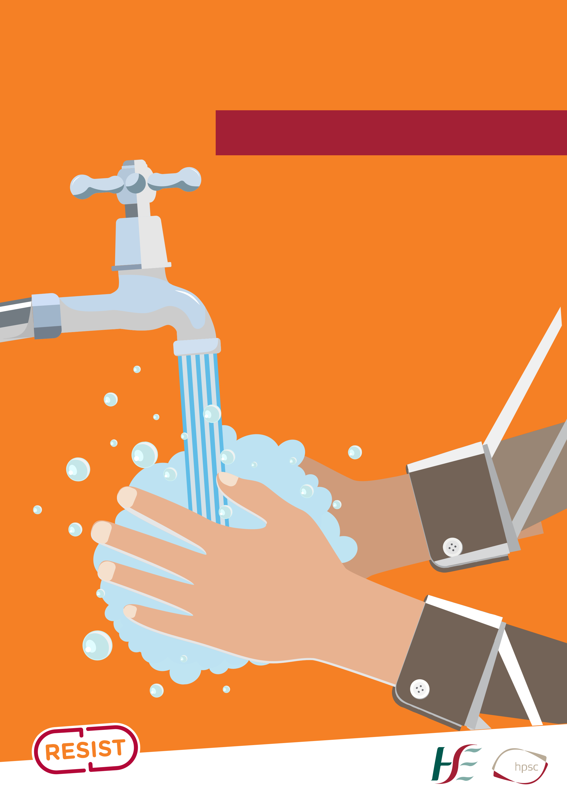
Protect yourself and others from getting sick

Wash your hands

• after coughing or sneezing • when caring for the sick • before and after you

prepare food

• before eating

• after toilet use

• when hands are visibly dirty

• after touching cuts, blisters or any open sores

• you can use alcohol hand rub, if hands are not visibly dirty

>INSERT LOGO<

