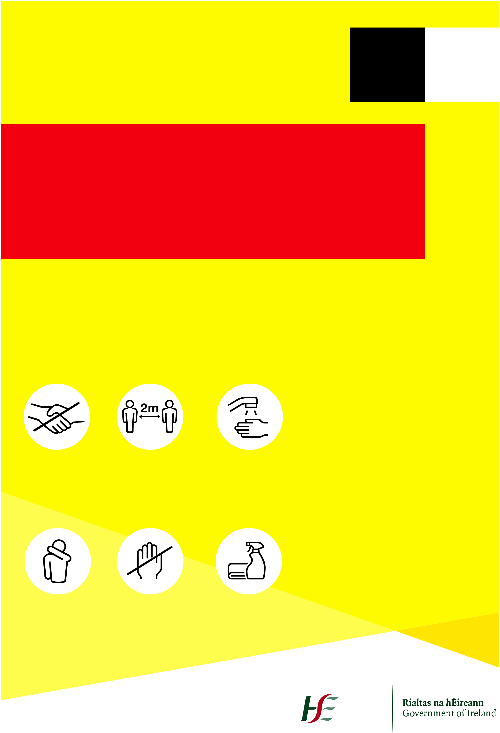
Coronavirus COVID-19
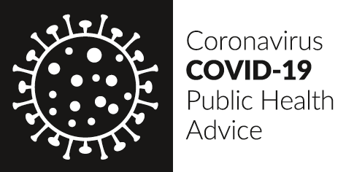

Coronavirus
COVID-19

Public Health
Advice

If you have fever and/or cough you should stay at home regardless of your travel or contact history.

If you have returned from an area that is subject to travel restrictions due to COVID-19 you should restrict your movement for 14 days. Check the list of affected areas on https://www.who.int

All people are advised to:

- Reduce social interactions

- Keep a distance of 2m between you and other people

- Do not shake hands or make close contact where possible

If you have symptoms phone (ENTER NATIONAL EMERGENCY NUMBER)

How to Prevent |  |  |  | Symptoms
 |  |  |  | > Fever (High Temperature)
 |  |  |  | > A Cough
 |  |  |  | > Shortness of Breath
 |  |  |  | > Breathing Difficulties
Stop | Distance | Wash |  | For Daily
 |  |  |  | Updates Visit
shaking hands or | yourself at least | your hands well and |  | (Enter national website)
hugging when saying | 2 metres (6 feet) away | often to avoid
hello or greeting | from other people, | contamination
other people | especially those who
 | might be unwell

>INSERT LOGO<
Cover | Avoid | Clean
your mouth and nose | touching eyes, nose, | and disinfect
with a tissue or sleeve | or mouth with | frequently touched
when coughing or | unwashed hands | objects and surfaces
sneezing and discard
used tissue

