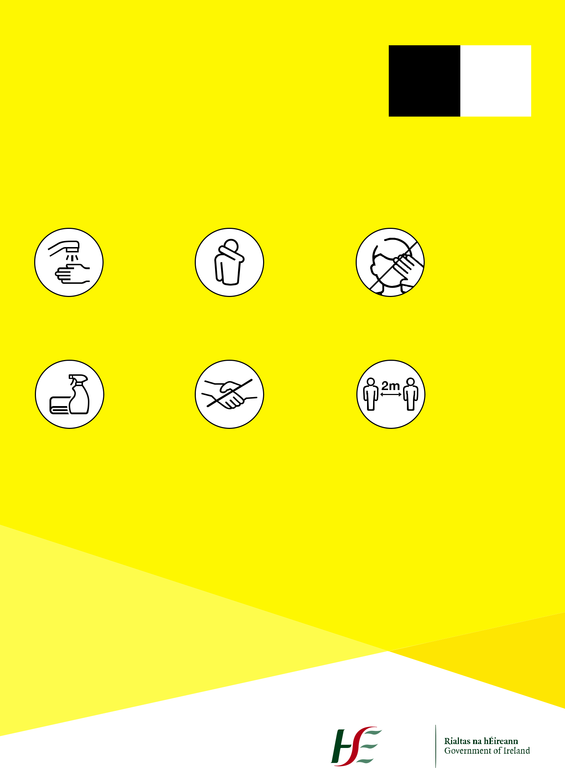
Coronavirus
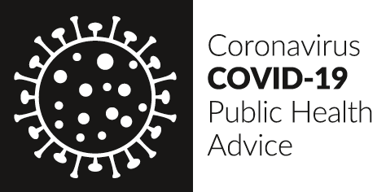

COVID-19

Help prevent coronavirus

Wash your | Cover mouth if | Avoid touching
hands | coughing or sneezing | your face

Keep surfaces | Stop shaking | Keep a safe
clean | hands and hugging | distance

The virus spreads in sneeze and cough droplets, so regularly taking the above measures helps reduce the chance of it spreading.

For updated factual information

>INSERT LOGO<
and advice or suspected case, Call
HSE: (ENTER NUMBER)
GP: (ENTER NUMBER)

Protection from coronavirus.

It’s in our hands.

